**EXPERIMENT-8**

# Monostable and Astable Multivibrator using 555 timer.

-----------------------------------------------------------------------------------------------------------------------------------------------------------------------------------------------------------------------------------------------------------------------------------------------------------------------------------------------

1. To Design a Mono-stable and A-stable Multi-vibrator using 555 timer.
2. To Verify the functionality of above circuits.
3. **Aim:**
4. **Specification:** circuit uses 555 Timer IC
5. **Apparatus**

**Hardware:**

1. Resistors (1.2k $Ω$, 2.2k $Ω$)
2. Capacitor (0.1uF,0.01uF, 10uF)
3. DSO
4. 555 Timer
5. Regulated Power Supply
6. Bread board
7. **Theory:**

**555 Timer IC:**

The 555 timer IC is one of the most popular and widely used integrated circuits in electronics. Developed in the early 1970s by Hans Camenzind for Signetics (now part of ON Semiconductor), the 555 timer has stood the test of time due to its simplicity, reliability, and versatility. It can be used in various configurations for different timing and waveform generation tasks. Here, we'll explore some common applications of the 555 timer, including its use as a mono-stable and a-stable multi-vibrator.

1. **555 Timer as a Mono-stable Multi-vibrator:**

In a mono-stable multi-vibrator configuration, the 555 timer produces a single output pulse in response to an external trigger. This mode is often referred to as a "one-shot" mode because the output pulse duration is determined by external components and occurs only once per trigger event.

**Operation:**

**Triggering**: A low signal (negative pulse) applied to the trigger input (pin 2) starts the timing cycle by causing the output (pin 3) to go high.

**Output Pulse Duration**: The duration of the high output state (T) is defined by the time constant of the RC network:

**T=1.1×R×C**

**Resetting**: Once the capacitor charges to 2/3 of the supply voltage (Vcc), the output returns to low, and the timer is ready for the next trigger.

1. **555 Timer as an A-stable Multi-vibrator:**

In the a-stable multi-vibrator configuration, the 555 timer generates a continuous square wave output. This mode is useful for creating oscillators and clock pulses.

**Operation**:

**Charging Phase**: When the output (pin 3) is high, the capacitor charges through resistors R1 and R2.

**Discharging Phase**: When the capacitor's voltage reaches 2/3 of Vcc, the output goes low, and the capacitor discharges through resistor R2.

**Repetition**: This cycle repeats, producing a continuous square wave. The times for charging (𝑇1) and discharging (𝑇2) are given by:

**T1 = 0.693×(R1+R2)×C**

**T2 =0.693×R2×C**

1. **Procedure:**
2. Connect the circuit as per the circuit diagram
3. Apply input as per the requirements and observe the outputs.
4. Observe the outputs of mono-stable and a-stable multi-vibrators using a CRO.
5. Note the outputs and compare the theoretical time periods with the practical values and also note the saturation values of op-amp.

**Design:**

1. Mono-stable: T = 1.1* 2.2k $Ω$*10uF = 24.2ms
2. A-stable: T1 = 0.693×(2.2k $Ω$ +1.2k $Ω$)×0.1uF = 235.62us

T2 = 0.693×(1.2k $Ω$)×0.1uF = 83.16us

1. **Circuit schematic of each application and their responses:**
2. **Mono-stable Multi-vibrator:**

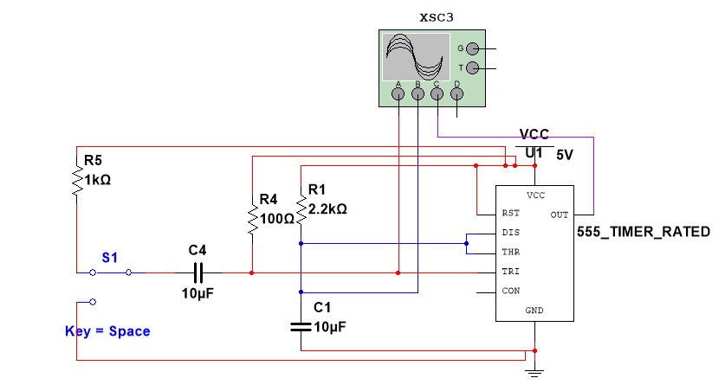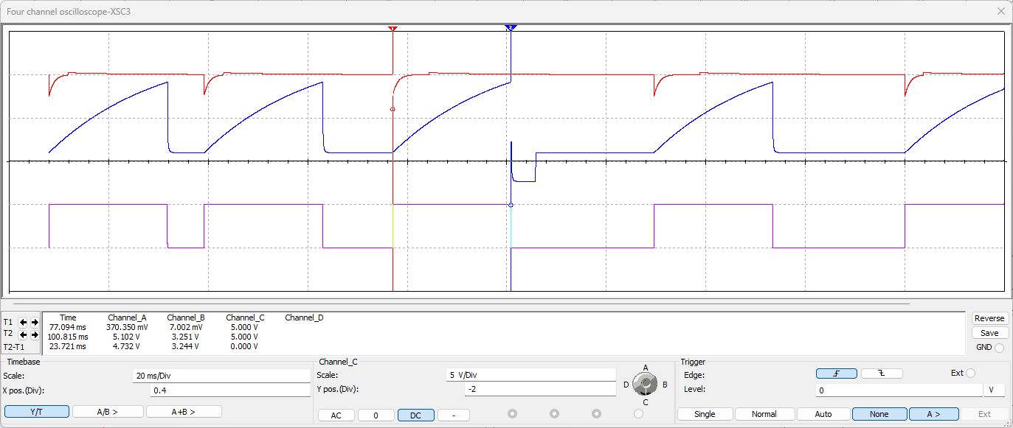

Fig-1: Mono-stable Multi-vibrator Circuit

**CONCLUSION:**

From the above response we can conclude that the duration of the high output state measured [23.721 ms] is equal to the theoretically calculated value, and output is high only after trigger is applied.

1. **A-stable Multi-vibrator:**

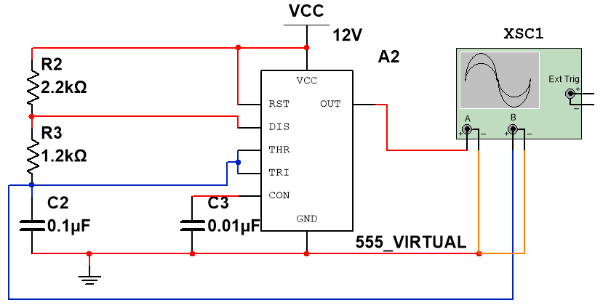 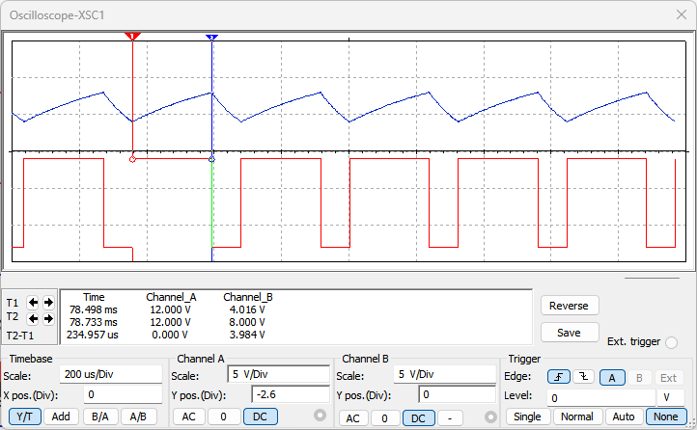

Fig-2: **A-stable Multi-vibrator Circuit**. Fig-3: **A-stable Multi-vibrator [ON State]**.

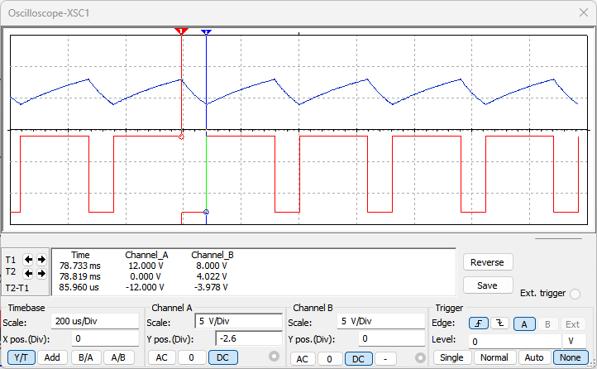 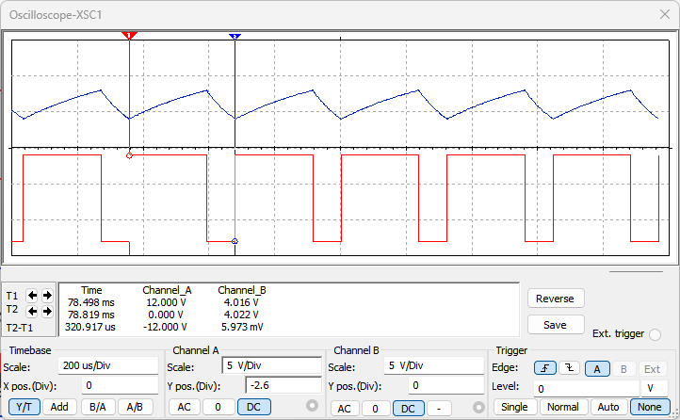

Fig-4: **A-stable Multi-vibrator [OFF State]**. Fig-5: **A-stable Multi-vibrator [T1 + T2]**.

**CONCLUSION:**

From the above response we can conclude that the duration of the high output state measured [234.957 us], low output state measured [85.960 us] are equal to the theoretically calculated values T1 and T2, and output is high when the threshold voltage[across capacitor] is less than $\frac{1}{3}V_{cc}$ during this phase capacitor charges up to $\frac{2}{3}V_{cc}$ and output is low when the threshold voltage[across capacitor] is greater than $\frac{2}{3}V_{cc}$ during this phase capacitor discharges causing continuous waveform without any external trigger i/p.

1. **Result:**

We have designed and implemented Mono-stable and A-stable Multi-vibrators using 555 Timer IC.

Signature of the Faculty